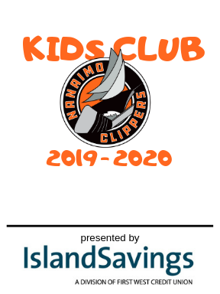
2019 – 2020 Nanaimo Clippers Kid Club Membership Includes:
- Exclusive Island Savings Kids Club T-Shirt
- Exclusive Kids Club Membership Card with Clippers Lanyard
- Exclusive tour of locker and team bus with Nanaimo Clippers Players
- Birthday Announcement over PA at a Game
- 1 Ticket to Clippers Home Opener
- Special Island Savings Kids Club Events
- + MORE!

Name: ________________________ Parents Name(s):______________________

Phone: _______________________ Email:________________________________

T-Shirt Size: ___________________ Birthday: _____________________________

Total cost to join the Nanaimo Clippers Kids Club is $25 for the Season.
Please return this form to Tali@NanaimoClippers.com

